Is just business, in the sense of business that is really just, possible?
When our president and his business buddies are grabbing what they can and ignoring the effect it has on the economy that must support the rest of us and our business, what are we supposed to do?
In the current political climate and the plunging economy, alongside more and more experiences working with incredible people, an increasing number of whom are black, I am beginning to ask some difficult questions about money, privilege, leadership and justice.
I have been reading Malcolm Gladwil’s Outliers and Blink and am understanding more and more the impact that opportunity, luck, heritage and culture has on one’s success and the tiny contribution made by talent and hard work. Then I read Deborah Cadbury’s account in Chocolate Wars of how the generations of hard work, Quaker honesty and business acumen that went into the Cadbury legacy was wiped out by the modern business practises that made hostile takeover possible – all that work gone. And I ask:
IS just business that is really just, just a myth?
And yet…
Aftern the people’s march this last Friday my faith in the people of South Africa was renewed. It was these same folks that did not stand for the injustice of apartheid that is not standing for the injustice of the current shenanigans. I know it will take much more to make the real diffence we want, yuet the solidarity was unmistaken. In the 80’s and early 90’s too there were those who wanted to use race as a way to drive us appart, but the fight against apartheid was fought by all races. Are there enough South Africans now that can stand for justice and against injustice? It certainly seemed like it on Friday.
Were you there? Did you experience the solidarity too?
This is the story about South Africa and its people that I want to fan into flame. Yes, I know that the road of justice is a hard one. It will lead to a place where I must accept the injustice done by my own forefathers against fellow South Africans’ fore fathers. And I must accept that these injustices has an ongoing structural effect on opportunities, privilege, luck and possibility. I also accept that I have to atone for this where I find meaningful opportunity to do so. Justice is our only way through this and we must seek it together. This is nowhere more so than in business if business is where we can build equal opportunity to earn a livelihood, care for our families, express our creativity and talents, and contribute to our communities.
Is just business possible?
Maybe when pigs fly?
So, please join the flying pig catchers as we explore
Trust and engaging Africa.

Trust and Engaging Africa
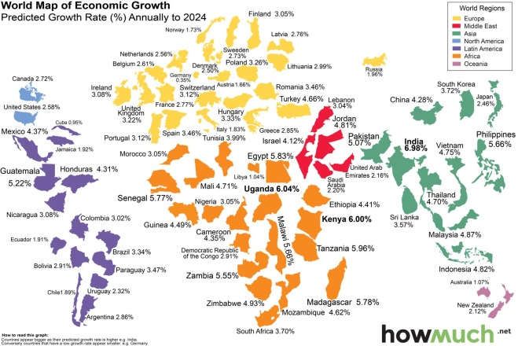

As a continent we may soon be digitally connected but can we be cohesively engaged to put ourselves on the world economic map?
Our pig for this session is the engagement of Africa.
Using Strategic Narrative Embodiment and the Dynamic Engagement Framework we will explore:
- How engagement changes outcomes
- The role of trust in engagement
- The character and faces of trust
- How we foster trust
Are we mad? Maybe a little!
Does this matter? Yes!
Can we be the agents of continental change? Why not?

Janet du Preez is a versatile leadership and organisational effectiveness practitioner and a passionate, provocative and creative thinker. A strategic people developer and engagement protagonist, she is constantly alert for good people, good ideas and good systems which can be made even more effective. Janet uses her well-honed coaching, facilitation, process development and strategic consulting skills to engage talent, passion, insight and action in pursuit of great leadership and effective systems. She is completing an MSc through the da Vinci institute developing a universal integrated sense-making framework for engagement in organisations.
Janet du Preez is a friend and accomplished flying pig catcher. she says about the SNE tools: "The SNE processes are a vital addition to my toolkit because of their creativity and impact. I am constantly seeking new ways to engage whole people in transformational journeys. SNE processes encourage new encounters with beliefs, thoughts, emotions, relationships and behaviours. When people engage themselves and engage with themselves in unexpected ways they learn and grow. We will not see change in the conditions in Africa until we transform who we are as Africans. We need every possible tool at our disposal to enable us to transform if we are to change our trajectory. SNE is a particularly powerful tool."
.
Janet is a versatile leadership and organisational effectiveness practitioner and a passionate, provocative and creative thinker. A strategic people developer and engagement protagonist, she is constantly alert for good people, good ideas and good systems which can be made even more effective. Janet uses her well-honed coaching, facilitation, process development and strategic consulting skills to engage talent, passion, insight and action in pursuit of great leadership and effective systems. She is completing an MSc through the da Vinci Institute developing a universal integrated sense-making framework for engagement in organisations.

